**Use Case: Play Game**

# Brief Description

The goal of this use case is to play the spelling game. Letters of the alphabet, a picture, and a number of spaces is shown. The user drags letters into the slots to spell the word that describes the picture shown.

# Included Use Cases

None

# Preconditions

Program is installed.

Student profile has been created. (See “Change Student”)

A Student has been selected on the student screen and the program is on the spelling game screen. (See “Start Game”)

# Flow of Events

## Basic Flow – The student plays the game

1. This use case begins when the student accesses the spelling game page.
2. The system creates the first word and picture.
3. The student drags letters into the spaces until the word describing the picture is spelled correctly.
4. The system stores the word in the history of the current student.
5. The system displays a new word and picture.
6. The student continues spelling words until there are 10 words spelled.
7. After 10 words, the game is over and the student goes back to the student page.
8. The use case ends.

## Alternative Flows

None

## Exception Flows

None

# Additional Detail

Appendices below.

# Requirements

None

# Post-conditions

1. The system has stored a history of the game played, which is linked to the selected student.

# Notes & Open Issues

None

# Out of Scope (Future Functionality)

## Animations and Sounds

Animations and sounds will play during the game when a letter is placed and completed.

## Choose Language

Ability to choose the language used between English and Hmong.

## Difficulty Levels

Have different levels of difficulty in terms of the words the student is asked to spell.

## Timed mode

An optional timed mode that will end the game after some amount of time.

## Additional Games

Include additional games that would further the goal of teaching phonics to a student.

# Appendix A – Data Definition for Play Game

Play Game: Data Definition

| **Field Name** | **Description** | **Type** | **Valid Values** | **Default** | **Business Rules** |
| --- | --- | --- | --- | --- | --- |
| Teacher | Teacher's name. | Text | N/A | N/A | Teacher names must be unique. |
| Student | Student's name. | Text | N/A | N/A | Student is assigned to a teacher. Student names must be unique. |
| Words | Words available to be spelled. | Text | N/A | N/A | Has the spelling of the word in all available languages. |
| History | History of spelled words. | Text | N/A | N/A | Consists of words spelled during the game. |

# Appendix B – UI Prototypes for Play Game

Play Game: UI Prototype

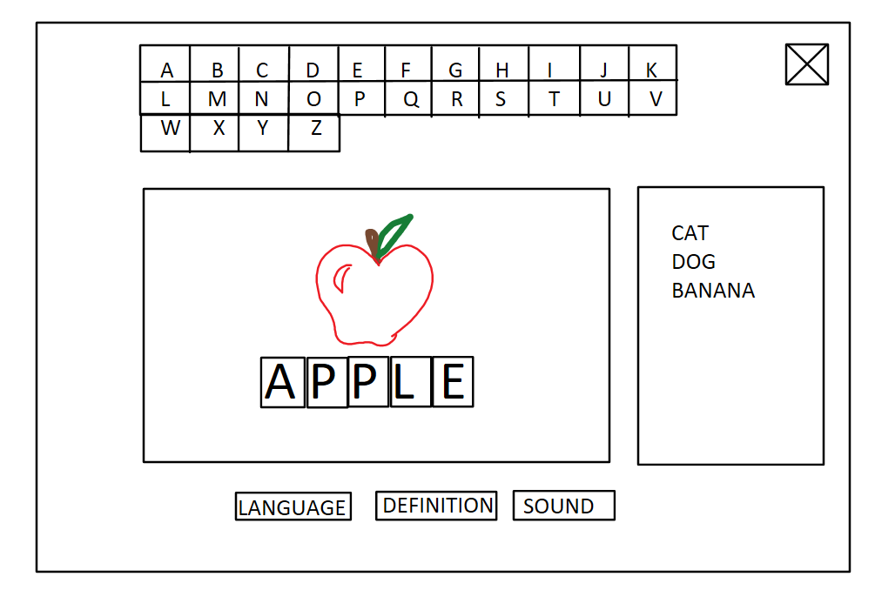

# Appendix C – State Machine for Play Game

Play Game: State Machine

